14.80: a) As in Example 14.8, the speed of efflux is 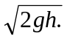 After leaving the tank, the water is in free fall, and the time it takes any portion of the water to reach the ground is 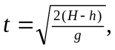 in which time the water travels a horizontal distance 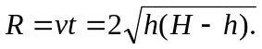
b) Note that if and so 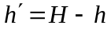 gives the same range. A hole 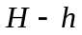 below the water surface is a distance h above the bottom of the tank.

